

**Course code :04170207**

**Course Name: Software Engineering Theory**

Project Name: Event Organizer

**Final Project**

Full Name:

Engy Ahmed Abd el-aziz ID:203024

Basmala Mohamed Zain ID:203032

Salma Essam Abdullah ID:203058

Dec 2020

Phase 2

Project: Event Organizer

Software Design Document

Software Engineering – 2020 – Software Design Document | 2

Month & Year

**Contents**

Team ................................................................................................................................................................... 3

Document Purpose and Audience ...................................................................................................................... 3

System Models...................................................................................................................................................4:26

I. Class diagrams ............................................................................................................................................ 4

Classes table…………………………………………………………………………………………………………………………………………….5

II. Sequence diagrams ..................................................................................................................................6:14

Class - Sequence Usage Table ..................................................................................................................... 15

III. Physical Entity-Relationship Diagram ........................................................................................................ 16

IV. Algorithms and Data Structures .............................................................................................................. 17:26

V. User Interface Design ................................................................................................................................ 27:34

VI. Dataflow diagram (DFD)……………………………………………………………………………………………………………………… 35:36

**Team**

|  |  |  |  |
| --- | --- | --- | --- |
| **ID** | **Name** | **Email** | **Mobile** |
| **203058** | **Salma Essam Abdullah** | Sim.salmaessam3058@alexu.edu.eg | 01210357949 |
| **203032** | **Basmala Mohamed zain** | Sim.basmalamohamed3032@alexu.edu.eg | 01205974265 |
| **203024** | **Engy Ahmed Abd El-Aziz** | Sim.engyahmed3024@alexu.edu.eg | 01114621092 |

**Document Purpose and Audience**

The Document is SDD document (Design of System), it explains how the application works and full design of the system through:

1- class diagram

2-sequence diagram

3-database design

4-Algorithm design

5-Data flow design

6-UI design

The target audiences are: project manager, CEO, programmers and customer

**System Model**

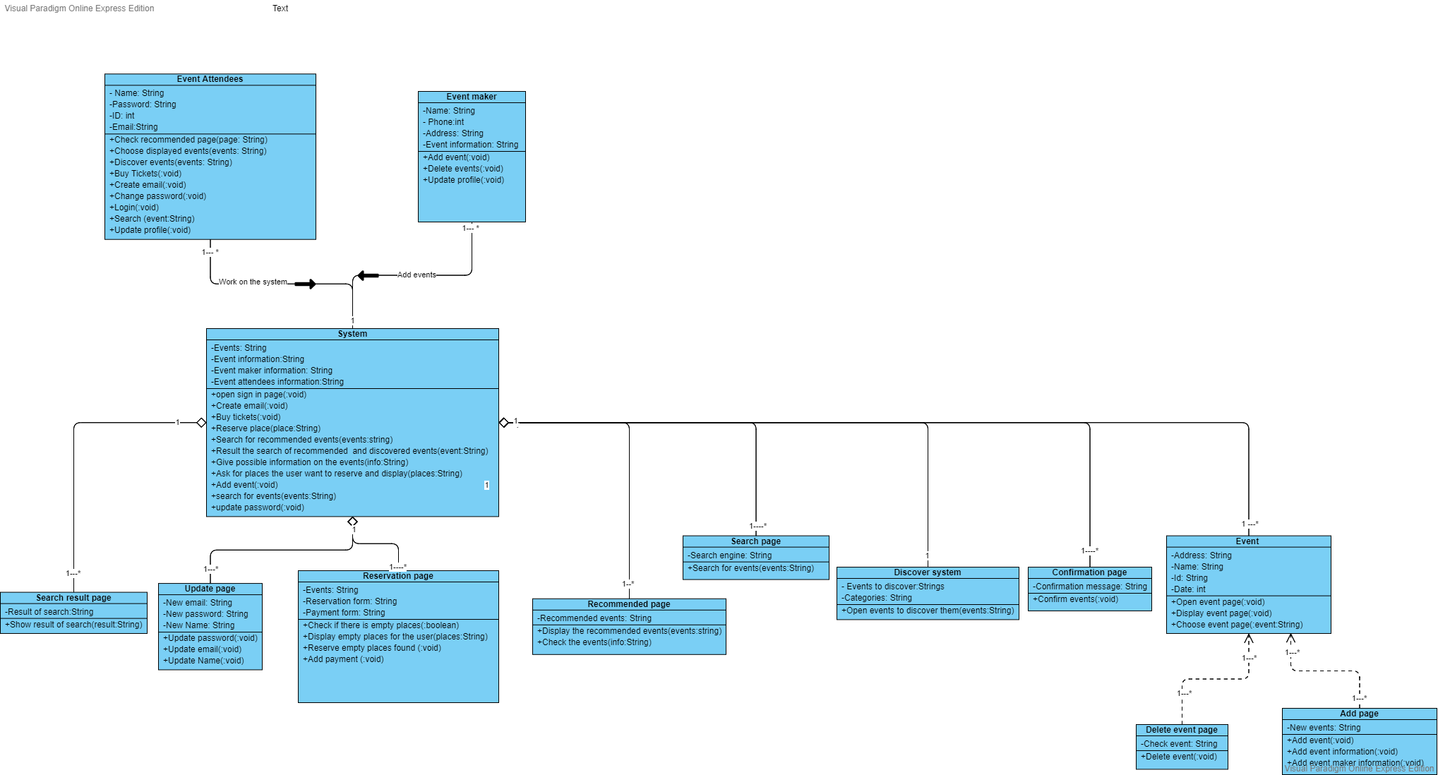**I. Class diagrams**

|  |  |  |  |
| --- | --- | --- | --- |
| **Class ID** | **Class Name** | **Subsystem ID** | **Description & Responsibility** |
| ID - 1 | System |  | Contain all pages and responsible of all processes occur as (searching, adding/deleting events, updating information ... etc.) |
| ID - 2 | Event attendees | ID - 1 | people who use the system to choose or discover events. |
| ID - 3 | Event Maker | ID - 1 | People who use the system to add events that event attendees would attend. |
| ID - 4 | Search Result Page | ID - 1 | a page in the system that show results of the search. |
| ID - 5 | Update Page | ID - 1 | a page in the system that used to update the profile of the users (change password, email …etc.) |
| ID - 6 | Reservation Page | ID - 1 | a page in the system used to reserve place in events. |
| ID - 7 | Recommended Page | ID - 1 | a page in the system used to show recommended events. |
| ID - 8 | Search Page | ID - 1 | a page in the system used to search for events. |
| ID - 9 | Discover System | ID - 1 | a page in the system used to discover new events. |
| ID - 10 | Confirmation Page | ID - 1 | A page in the system that shows confirmation message when event is added successfully. |
| ID - 11 | Event | ID - 1 | A page in the system that show all information about the event. |
| ID - 12 | Delete Event Page | ID - 11 | A page that used to delete event. |
| ID - 13 | Add Page | ID - 11 | a page that used to add events. |

**II. Sequence diagrams**

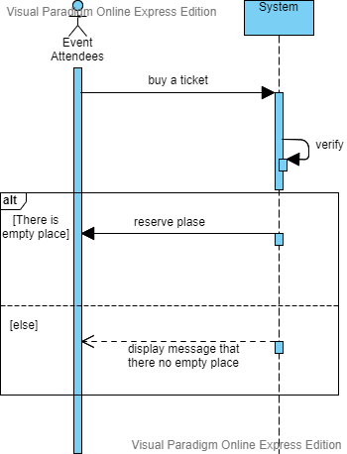**ID(1) Buy tickets:**

Buy Ticket:

**ID(2)** Create Email:

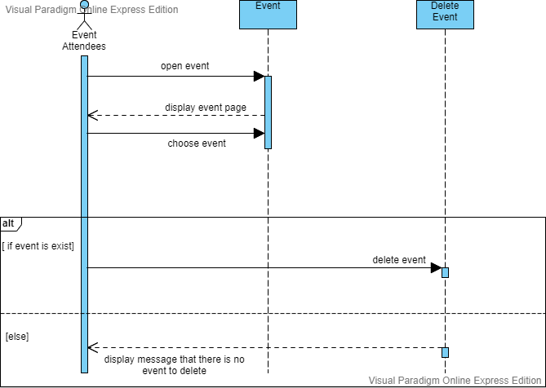

**ID(3)** Delete events: 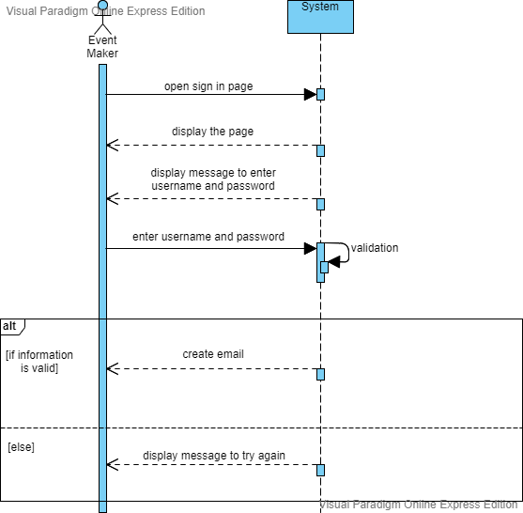

**ID(4)** 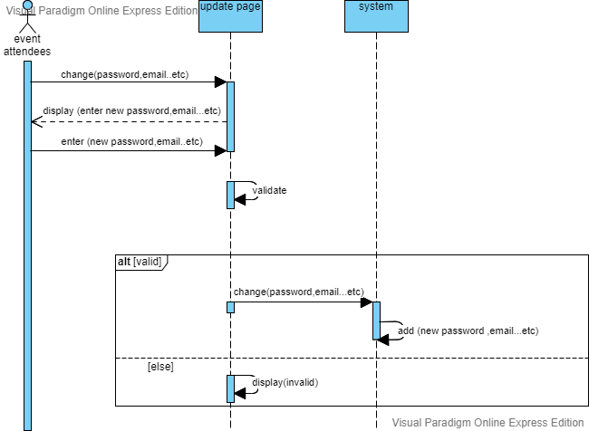Update profile:

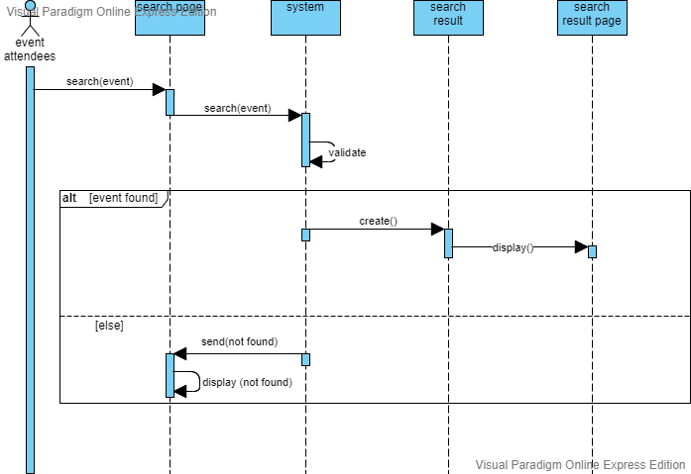**ID(5)** Search:

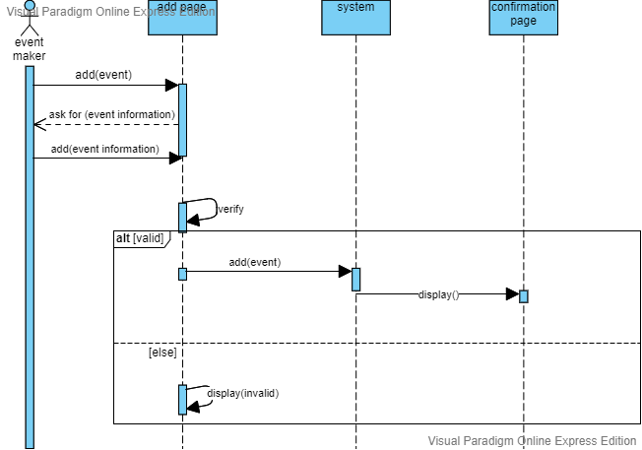**ID(6)** Add event:

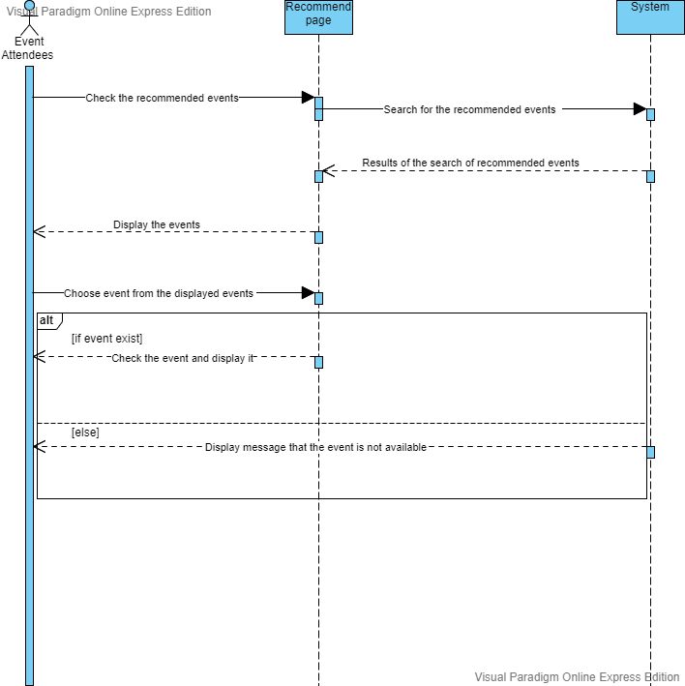**ID(7)** View recommended events:

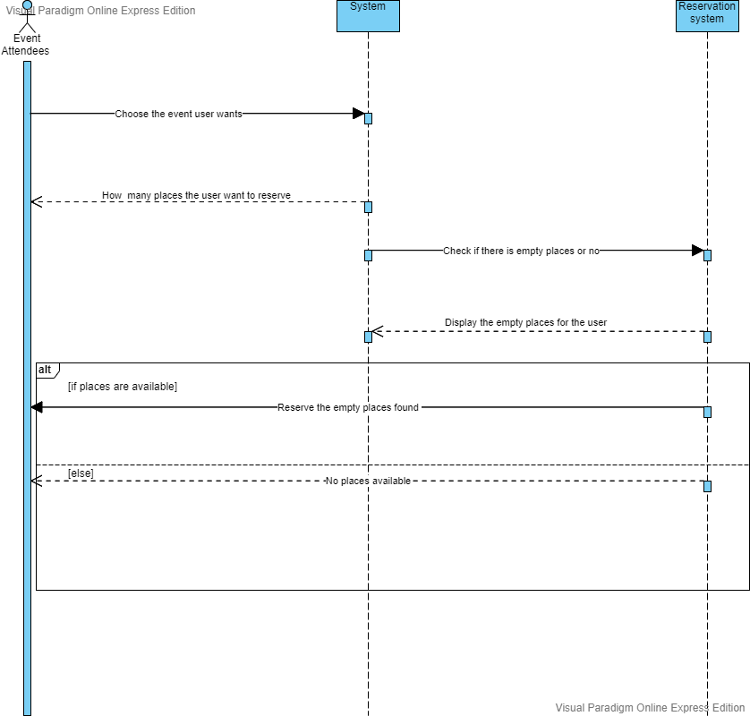**ID(8)** Attend created events:

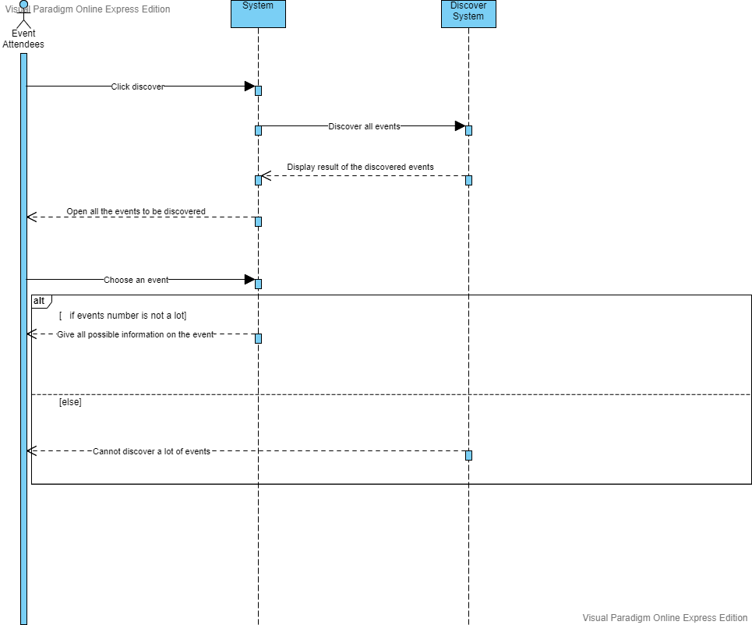**ID(9)** Discover events:

Class - Sequence Usage Table

|  |  |  |
| --- | --- | --- |
| Class Name | Sequence Diagrams | Overall used methods |
| Event | ID - 3 | -Open event page, Display event page, Choose event Page |
| Delete Event | ID - 3 | -Delete event |
| Recommended Page | ID - 7 | -Display the recommended events, Check the events |
| System | IDs – 1,2,3,4,5,6,7,8,9 | -Open sign in page, Create email, Buy tickets, Reserve place, Search for recommended events, Result of search of recommended and discovered events, Give possible information on the events, Ask for places the user want to reserve and display events, Add event, Search for events, Update password |
| Event Attendees | IDs -1,2,3,4,5,7,8,9 | -Check recommended page, Choose displayed events, Discover events, Buy tickets, Create email, Change password, Login, Search, Update profile |
| Discover System | ID - 9 | -Open events to discover them |
| Reservation Page | ID - 8 | -Check if there is empty places, Display empty places for the user, Reserve empty places found, Add payment |
| Event maker | ID - 6 | -Add event, Delete events, Update profile |
| Search result page | ID - 5 | -Show result of search |
| Update Page | ID - 4 | -Update password, Update email, Update Email |
| Search Page | ID - 5 | -Search for events |
| Confirmation Page | ID - 6 | -Confirm events |
| Add Page | ID - 6 | -Add event, Add event information, Add event maker information |

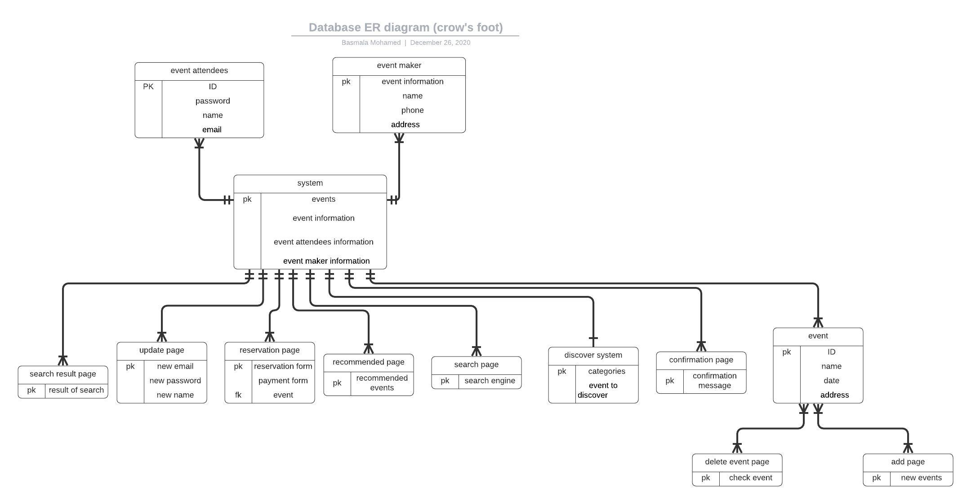III. Physical Entity-Relationship Diagram

**VI. Algorithms and Data Structures**

**Buy tickets:**

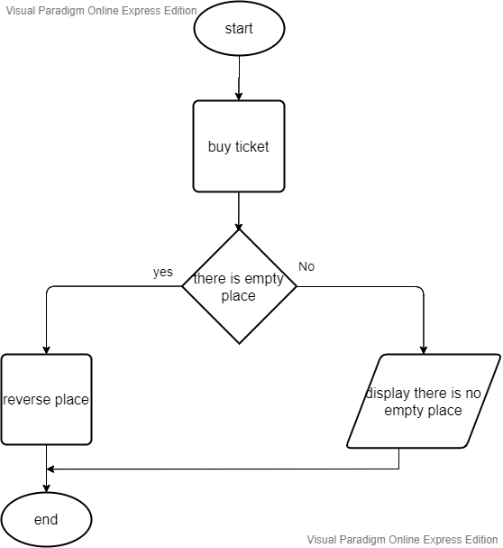

Create Email

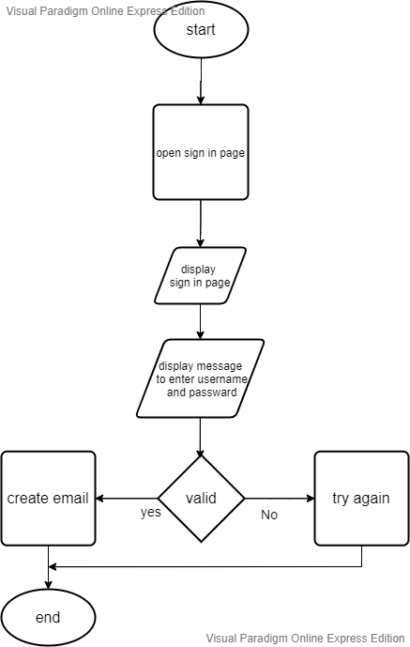

**Delete events:**

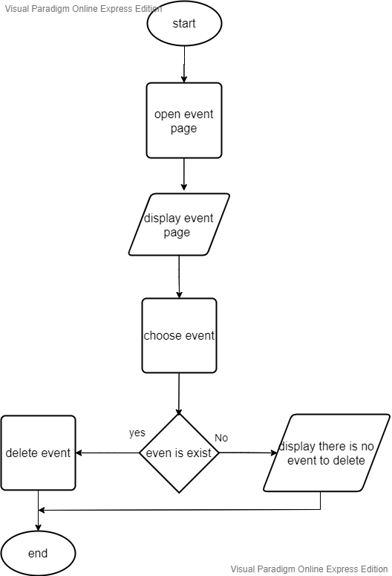

Update profile

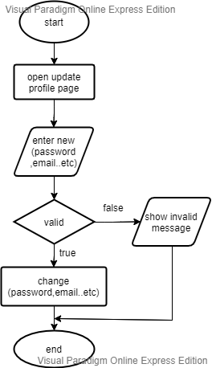

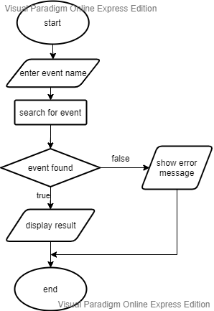  
search for event

Add event

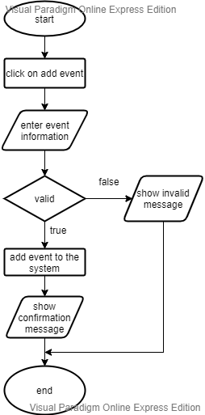

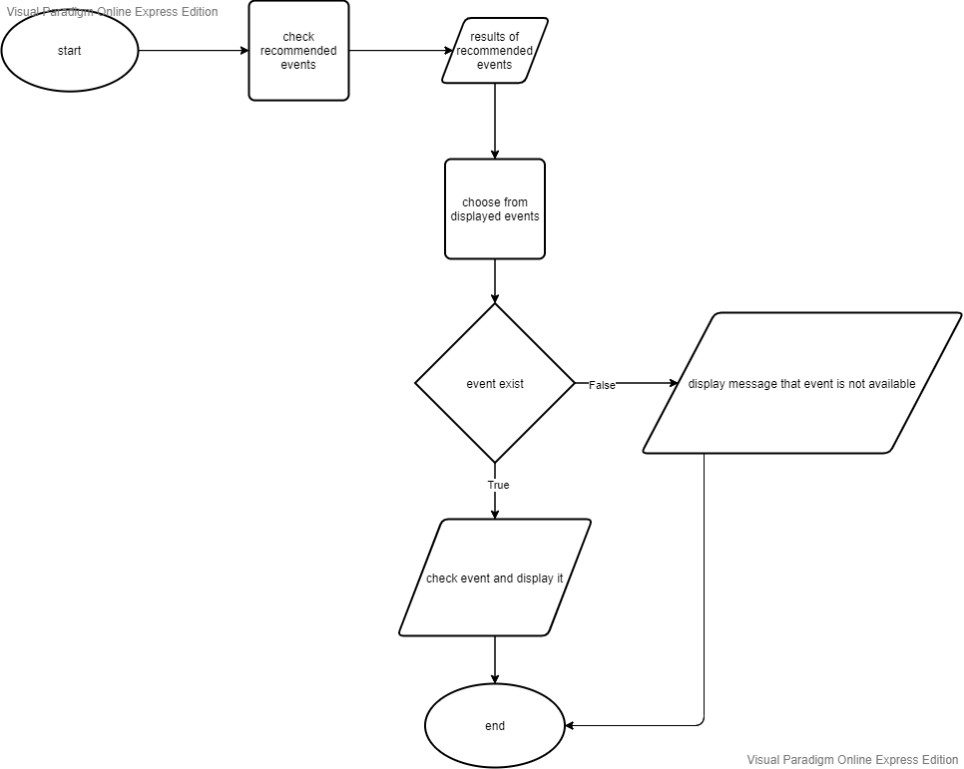View recommended events:

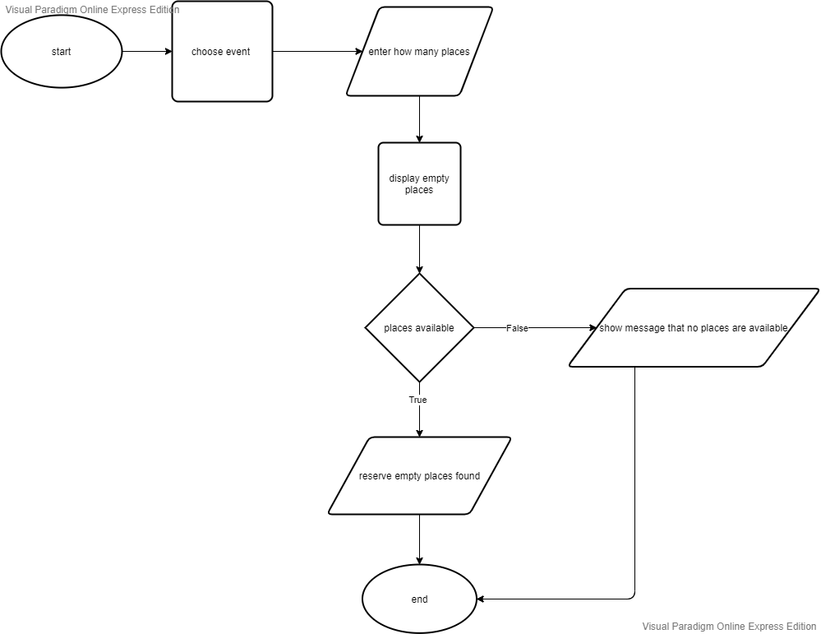Attend created events:

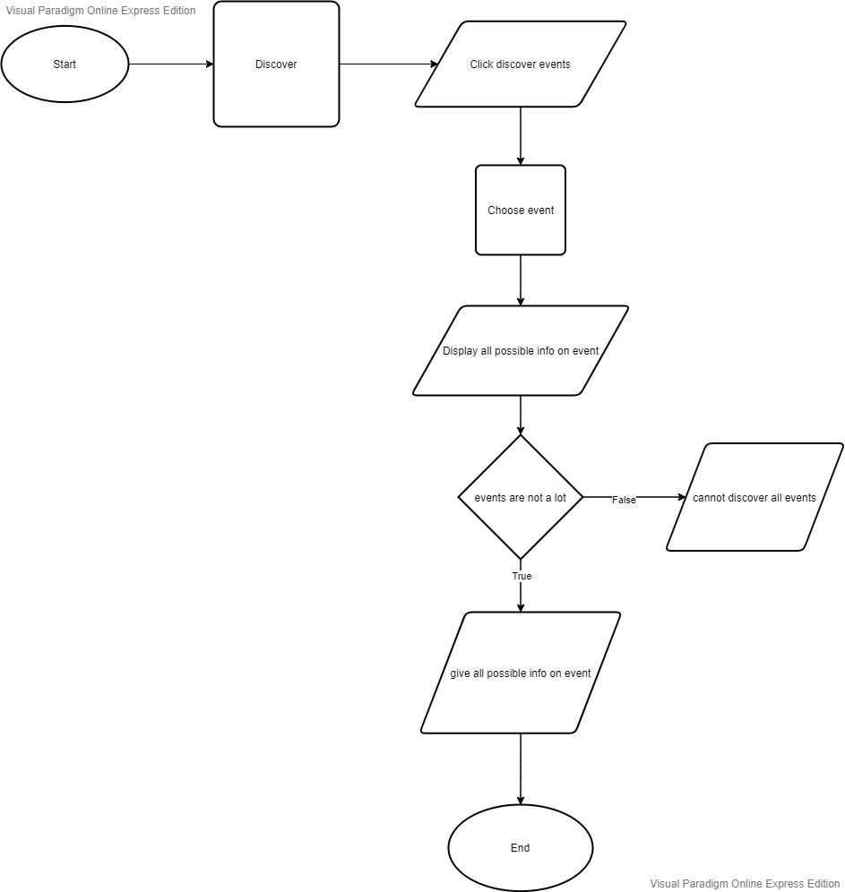Discover events:

ttt

The used data structure is linked list

We used linked list because we will have list of customer’s names and we want to add and remove items from it

**IV. User Interface Design**

Screen 1-Login

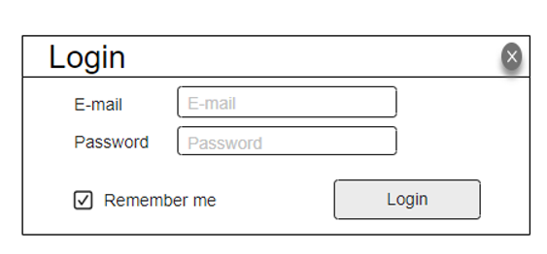

Screen 2-Main Interface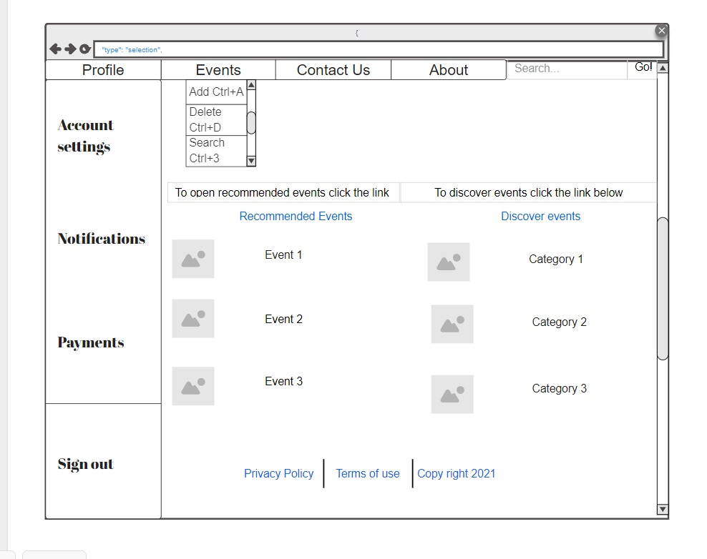

Screen 3- Buy Tickets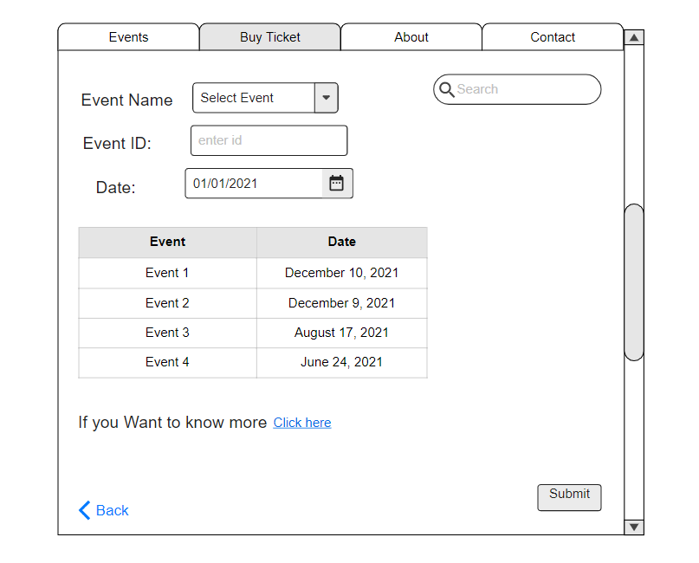

Screen 4- Create Email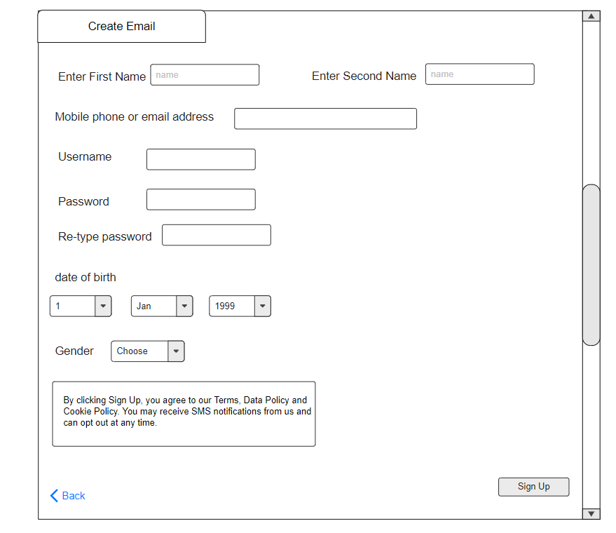

Screen 5- Delete Event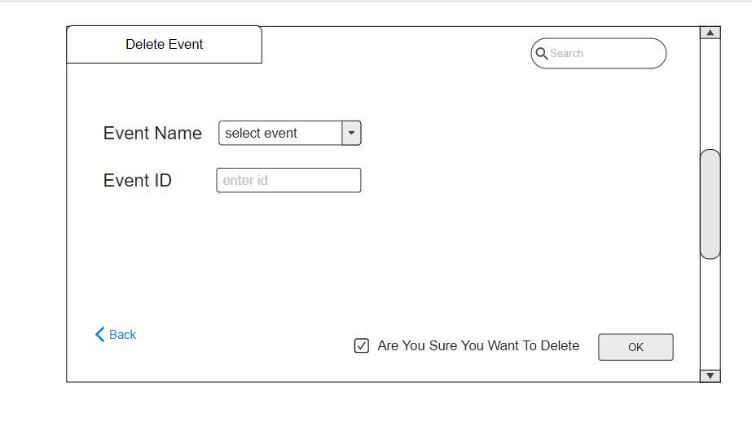

Screen 6 - Discover Events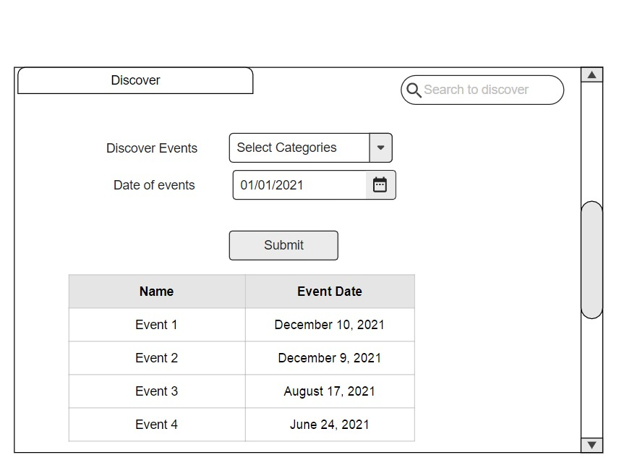

Screen 7 - Attend created events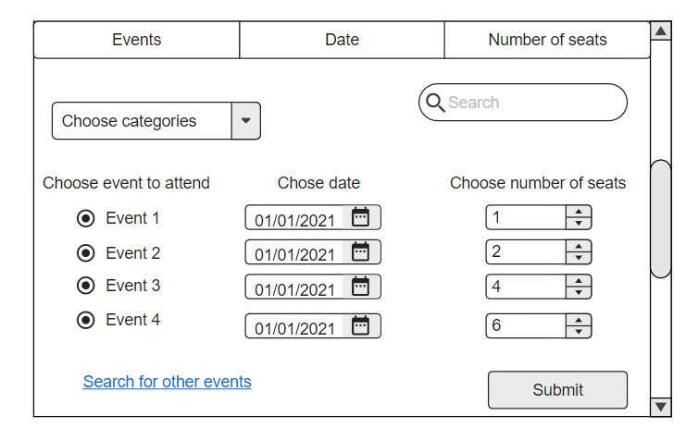

Screen 8 - Recommended Events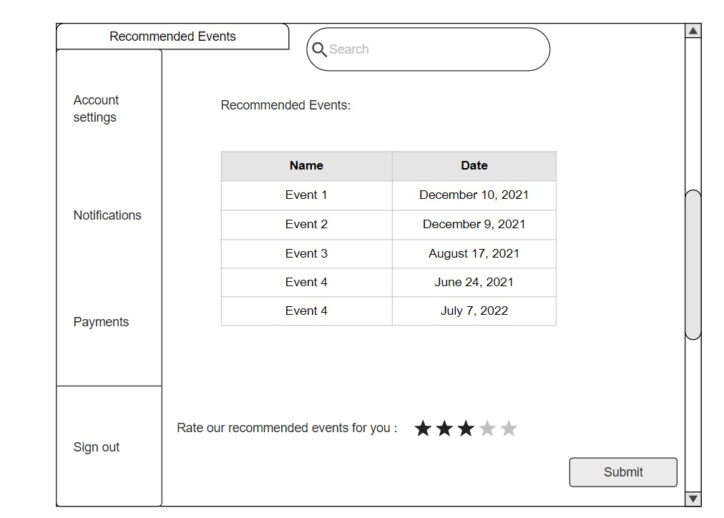

Screen 9- Search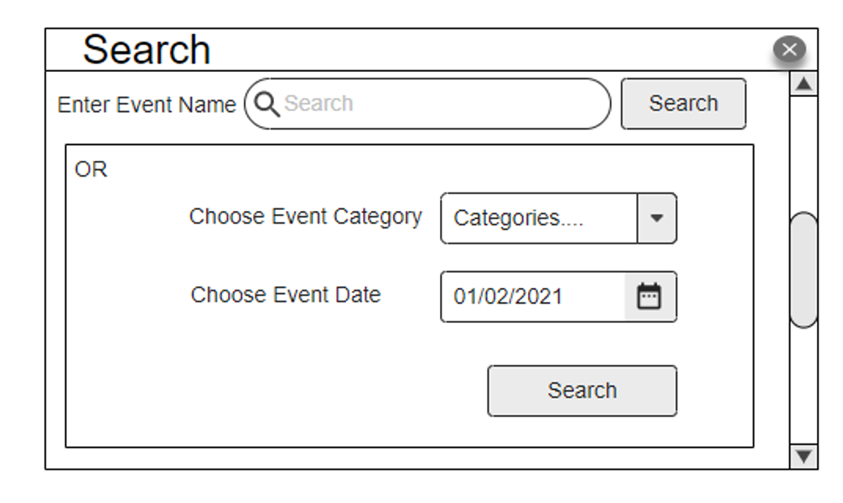

Screen 10 - Add Event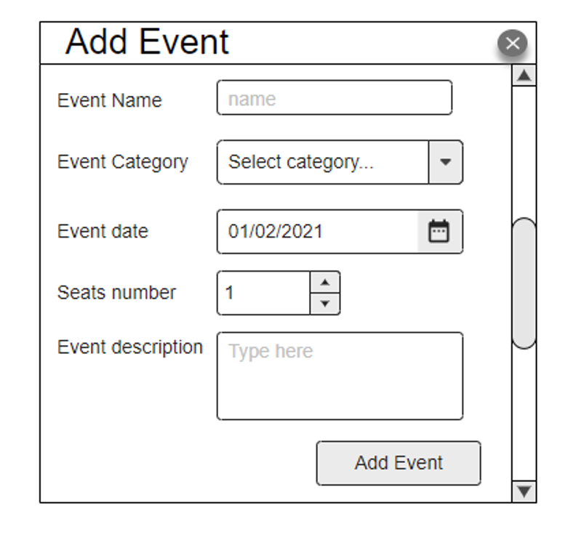

Screen 11 - Update Profile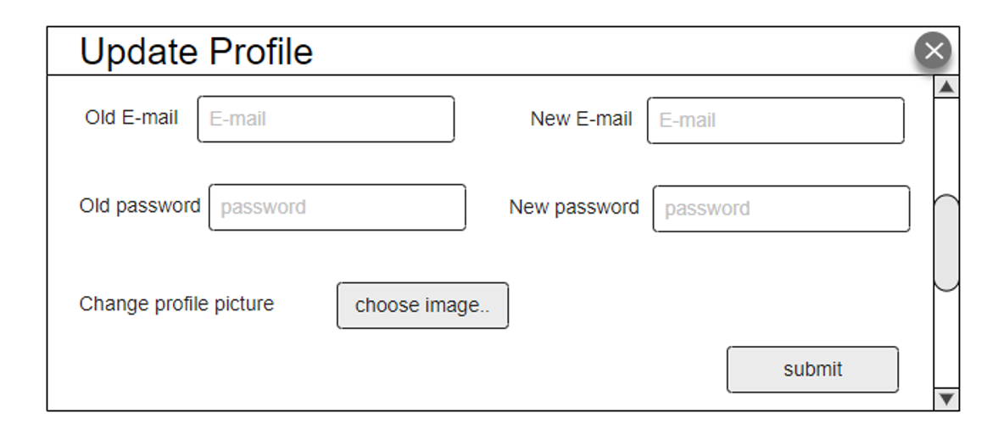

Navigation tree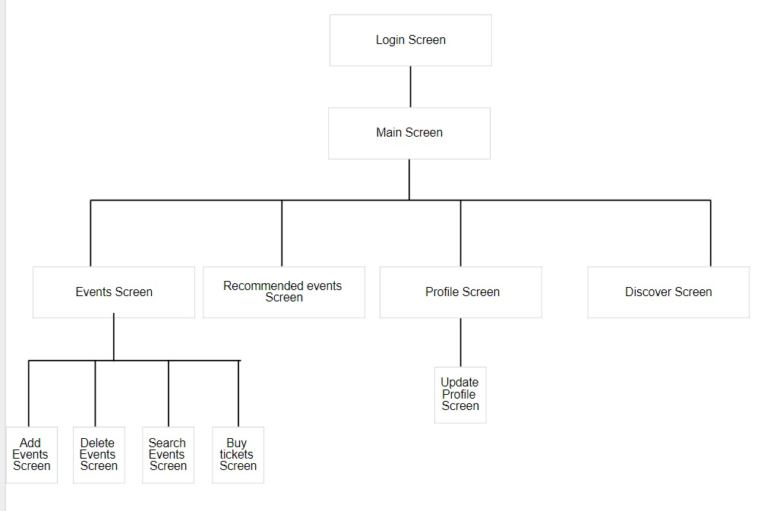

**V. Dataflow diagram (DFD)**

**Level 0**

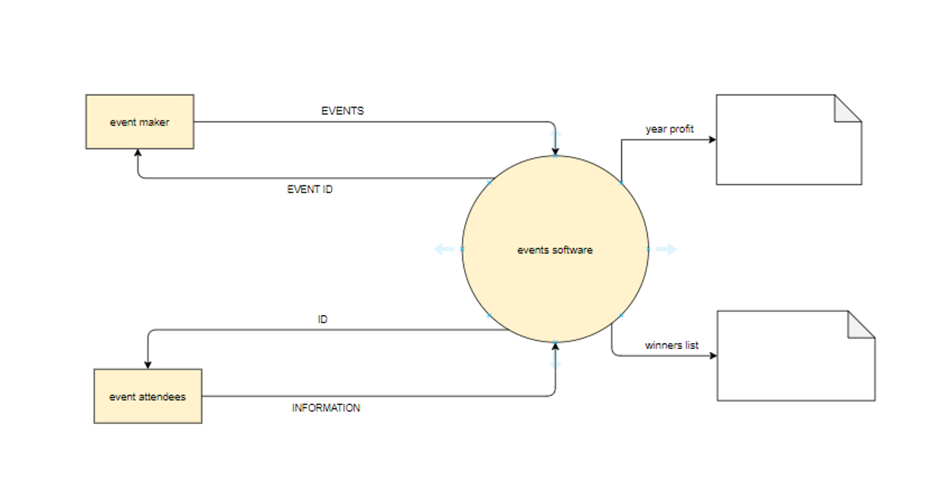

**Level 1**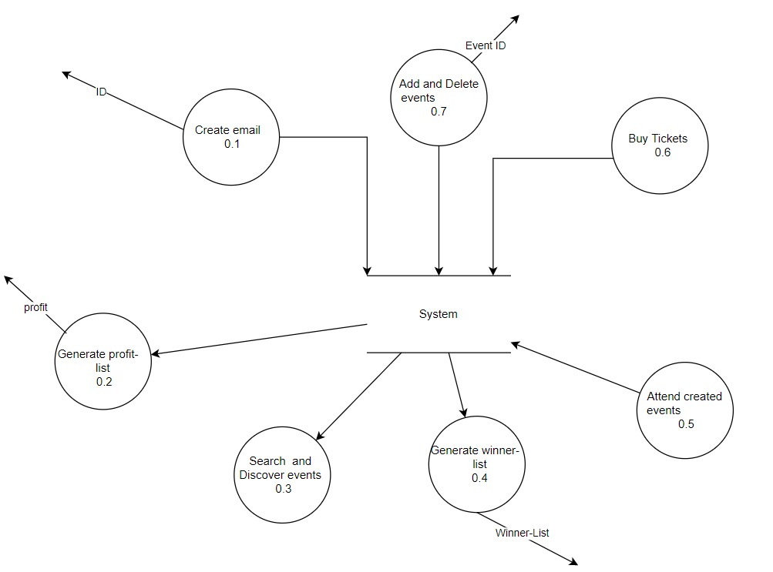

**Ownership Report**

|  |  |
| --- | --- |
| **Item** | **Ownership** |
| Class Diagram | Salma, Basmala, Engy |
| Sequence diagram | Salma, Basmala, Engy |
| Physical Entity-Relationship Diagram | Salma, Basmala, Engy |
| User Interface Design | Salma, Basmala, Engy |
| Dataflow diagram (DFD) | Salma, Basmala, Engy |
| Algorithms and Data Structures | Salma, Basmala, Engy |